1. In Quote Comments-In Web table- Need to remove empty space - Closed---Fixed

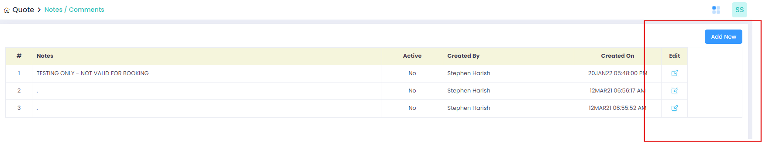

1. In Quote Comments-In Add Airport-Once data get enter and click Add to list button data get saved but pop wont closed.It need to close once data saved – ClosedThis is not a bug. This type of popup closes only when you manually click the close button-Accepted
2. In Quote Comments-In Add Customer-Once data get enter and click Add to list button data get saved but pop wont closed.It need to close once data saved - Closed -Accepted
3. In Pricing-Price Rules-In Tail group-After click Choose tail button, once click select all checkbox and click add to list button, data is not added. - Closed---Data is added but not listed in the webtable, only one tail is displayed in the table but I have select all checkbox.

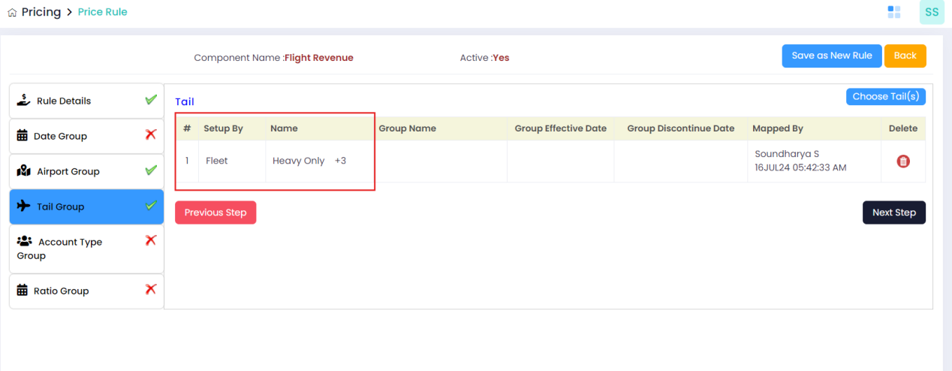

1. In Pricing-Price Rules-In Account Type-After click Choose tail button, once click select all checkbox and click add to list button, data is not added. - Closed--Fixed
2. In Pricing-Excel Upload-View History-

* After select the from month and click the search button details displayed improper alignment - Closed---Fixed
* scroll option is also not working--Fixed
* Download option is also not working--NotWorking-When Click download button navigates to previous page

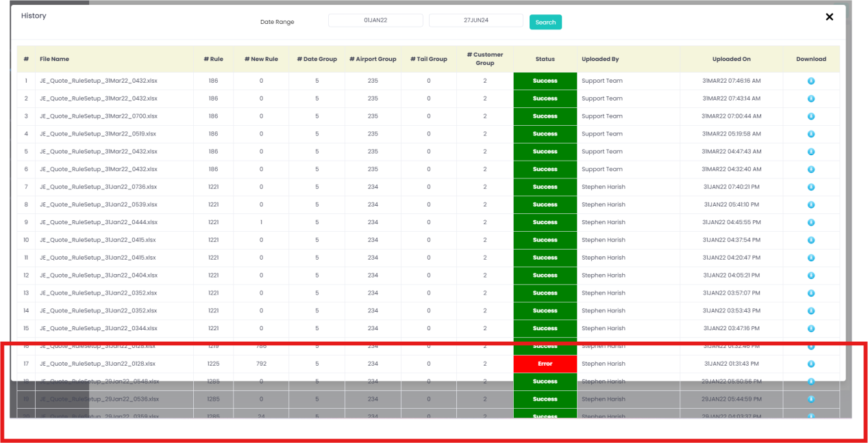

1. In Groups-Ratio Group-Once click the ratio group button, “Un Handled Exception” alert message is dispalyed. And Data cannot able to save. – The stored procedure is missing on the live . Once it's added, this issue might not occur anymore Fixed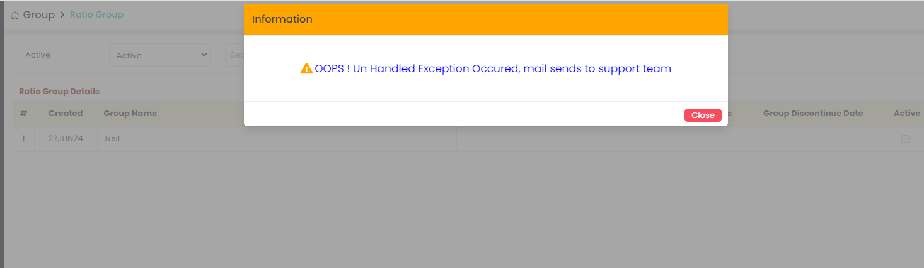
2. In Masters-User Setup-Add New-In User details, without enter any detail and click save button mandatory alert message is not displayed. - Closed--Fixed
3. In Pricing-Excel Upload-”**[Download Validation Rule File](javascript:__doPostBack('ctl00$cpWheelsUp$lnkDwValRuleFile','')" \o "Click here to download the validation Rule File)” button is not working**--Fixed

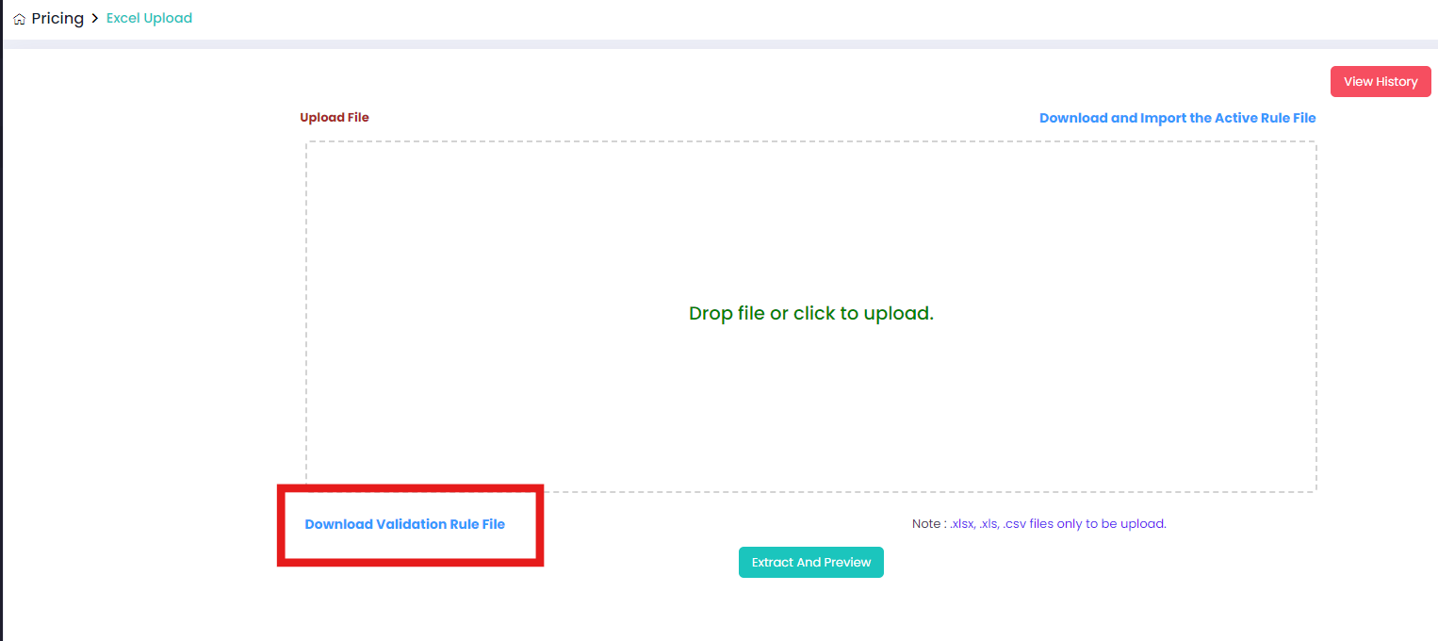

1. Masters-Tax Setup-Click Edit button -Page gets strucked and it wont able to reload properly. -Cleared--Not Fixed
2. Reports-Error Log Report is getting crashed. - Cleared--Fixed

12.Wind Temp-Season Setup-once change the season and click clear button its not working. “Clear button is not working”. – Season dropdown ID was Comment for some Reason---It will work or not?-Fixed

13.Quote-Quote list-Click view button-After click expand button in price formula, un handled alert message is displayed. - Closed-Not Fixed-Again it was showing---No data showing

14.Pricing-Price rules-Once click the copy button in webtable and click copy button unknown alert message is displayed - Closed--Fixed

15.Pricing-price rules-Account type group-After click choose account type button and page shows web table. But in the table un wanted box is displayed. - Closed--Fixed

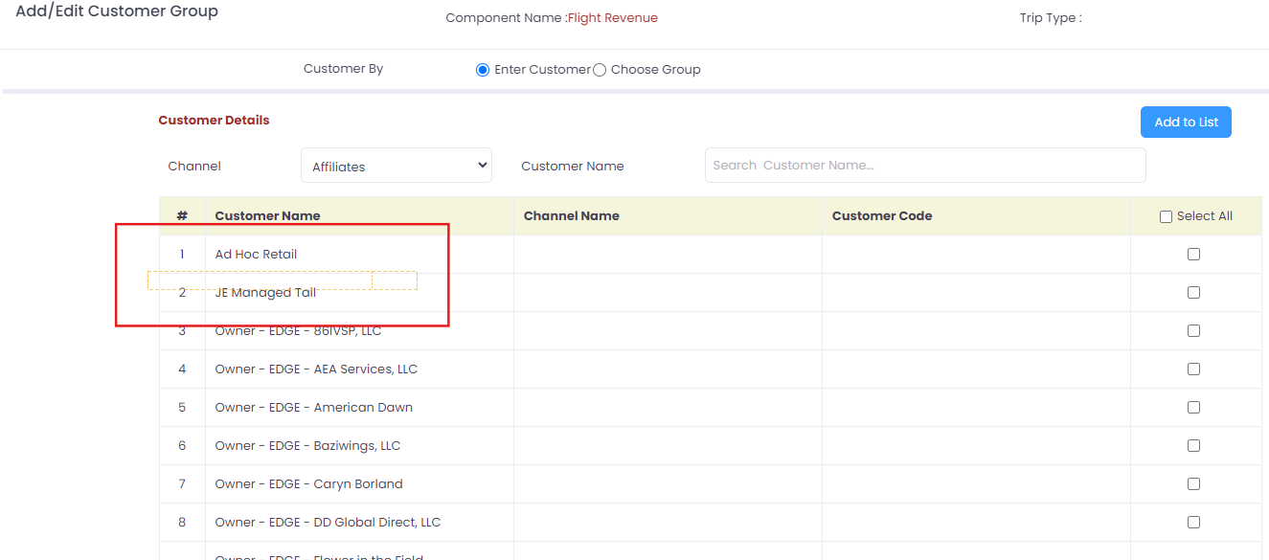

16.Groups-Airport Groups-Add new- When Click group effective date and Group discontinue date two different type of calendar is opened. - Closed--Fixed

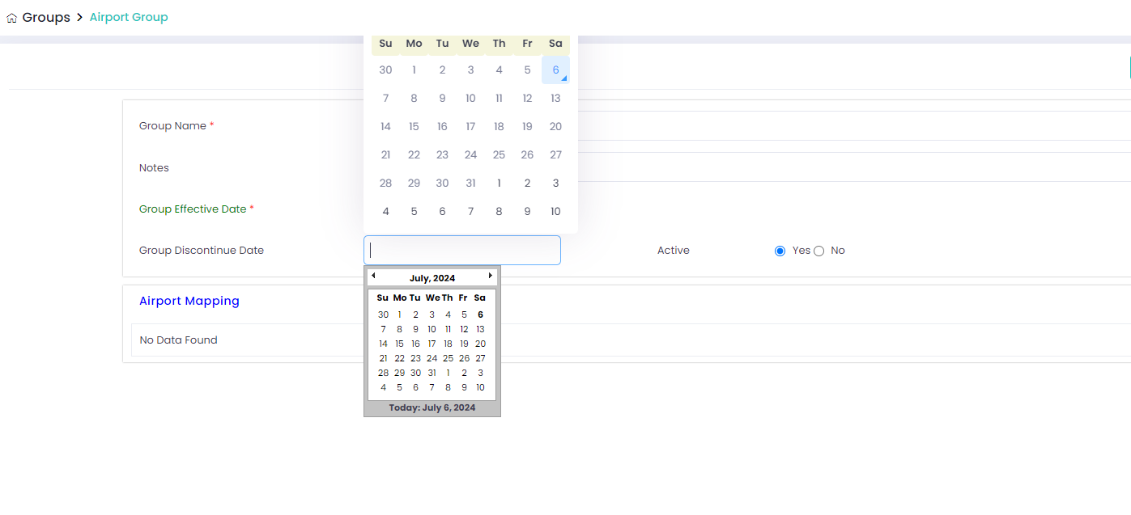

1. Groups-Airport Groups-Add new-After enter valid details and click save button, page shows saved successfully message but in web table saved data is not shown. - Closed--Fixed
2. Masters-Price formula-Add new-When select the airport details and click clear button it won’t clear. - Closed it is not bug , we have an option to clear the data for the chosen state, while the remaining records will stay constant.-Fixed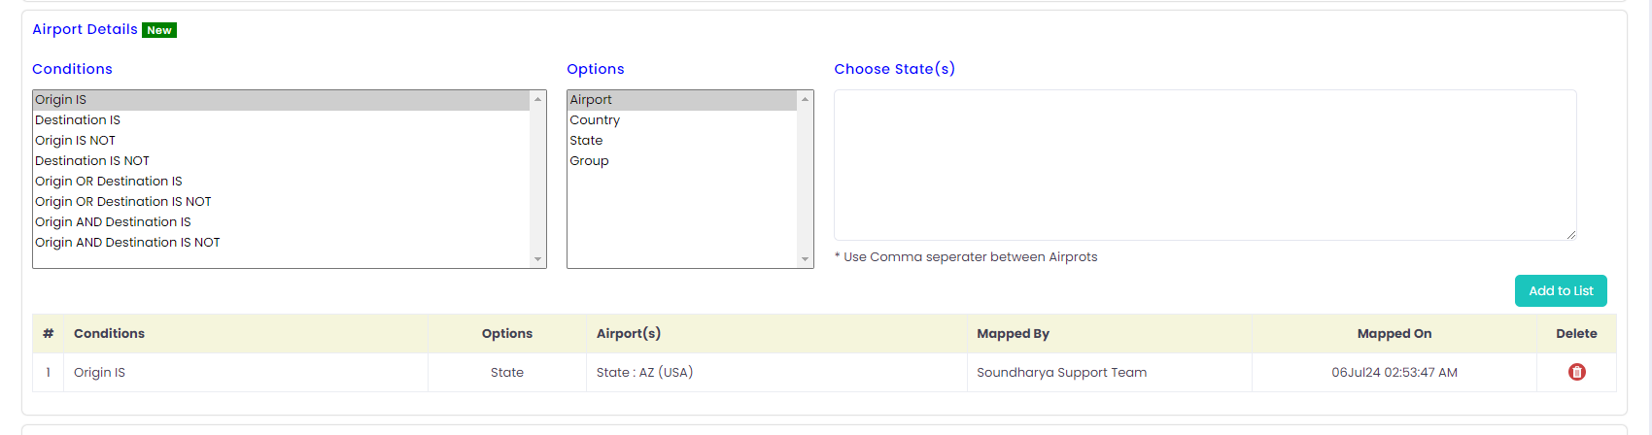
3. Masters-Components-Add new- Component code mandatory symbol is not present. - Closed--Fixed

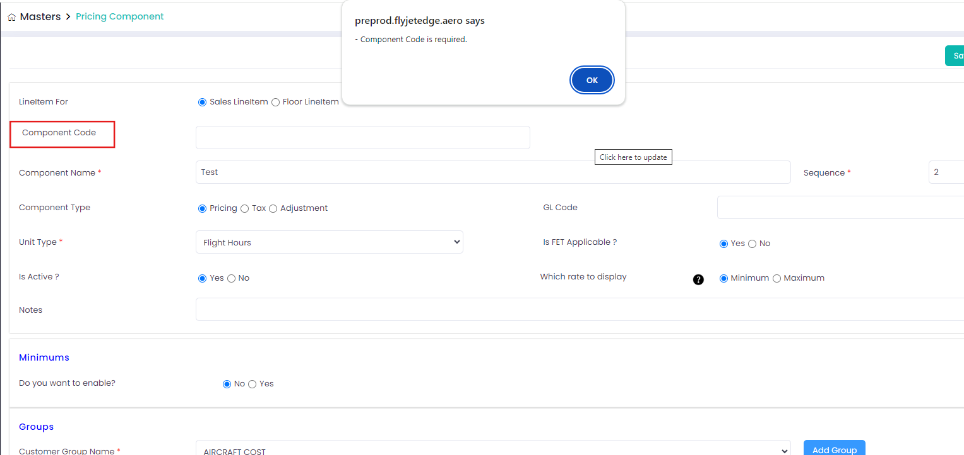

1. Masters-User setup-Add new- Without enter any details and click save and continue button, no mandatory alert message is displayed - Closed--Fixed

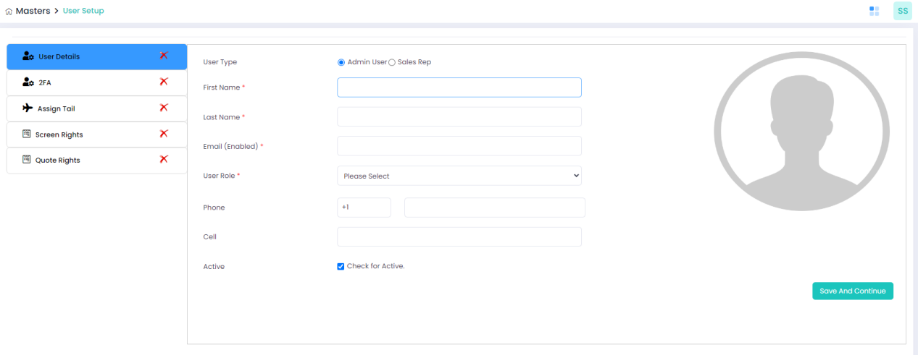

1. Masters-User setup-Add new-When enter valid details in user details and 2FA tab. After that, select valid assign tail radio button and click submit button, page shows sucessful message but data is not updated and also “X” symbol is not changing. - Closed--Fixed

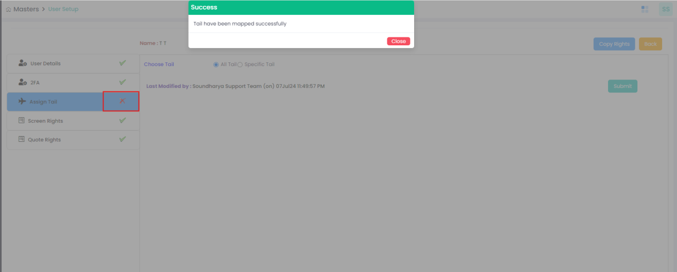

1. Masters-Account-Add new-After enter valid details in account details, In contact details after click add contact button unwanted allert message is displayed. - Closed---Fixed

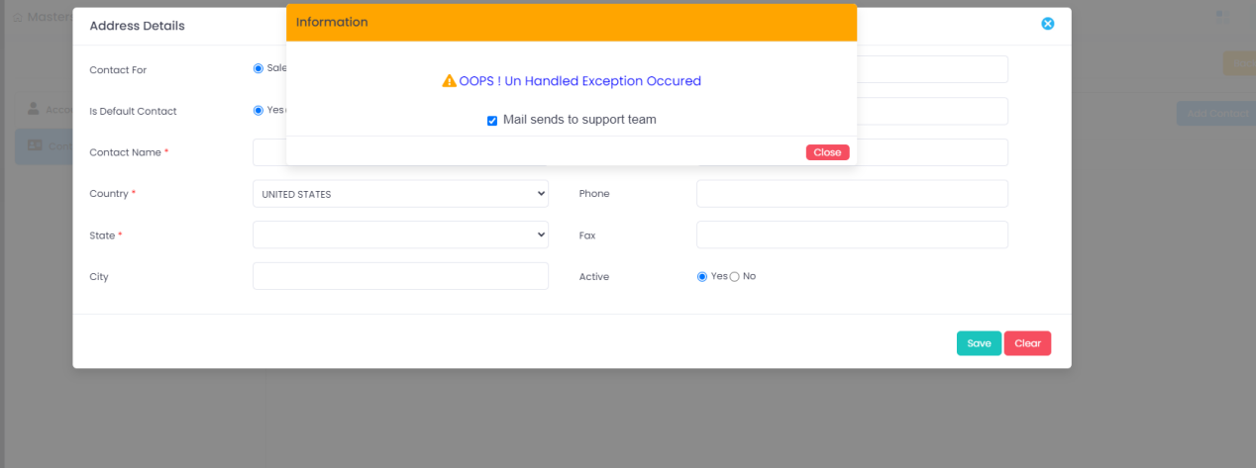

1. Masters-Flight hour setup – currently we are not using this screen and it only using the wind Temp Calculation-Confirm here to No need to test this module

* Click add new button in fore flight API tab, unwanted alert message is displayed
* Click edit button in fore flight API tab, unwanted alert message is displayed

1. Masters-Flight hour setup-In Great circle mapper tab, after click add new button and enter valid details in every field and click save button. Page shows data saved sucessfully but in web table fleet value is empty. – Currently we are not using this screen and also using only wind Temp Calculation -Confirm here to No need to test this module

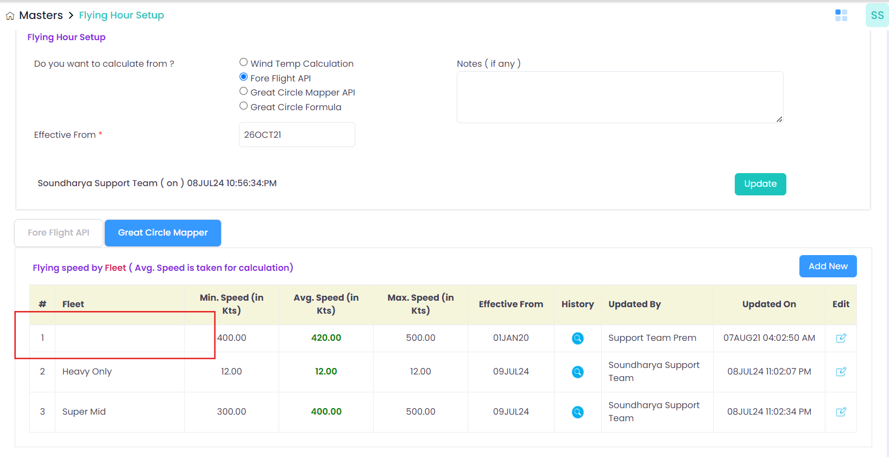

1. Masters-Flight hour setup-In Great circle mapper tab, Delete option is not present. – Gridview also didn’t have delete functionality process-Confirm here delete option is no needed

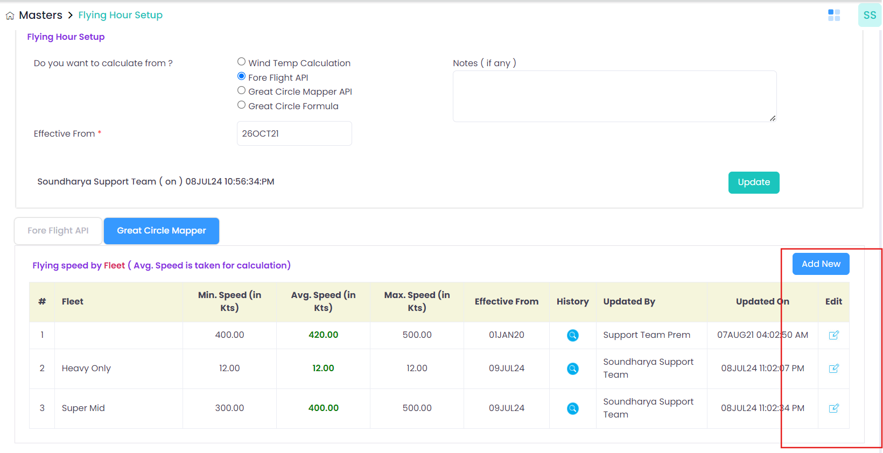

1. Masters-Airport setup-Add new-Without enter any value in airport details and click save button, mandatory alert message is not displayed. - Closed
2. Reports-User Report-Search functionn is not working. When enter valid user name with valid from and to date, table shows “No data found”. - Closed--Fixed
3. Reports-Event log report- there is two wind temp tabs in the screen. Need to know the purpose. – Live data also have 2 Wind Temp modules-Confirm here is that okay having two same modules

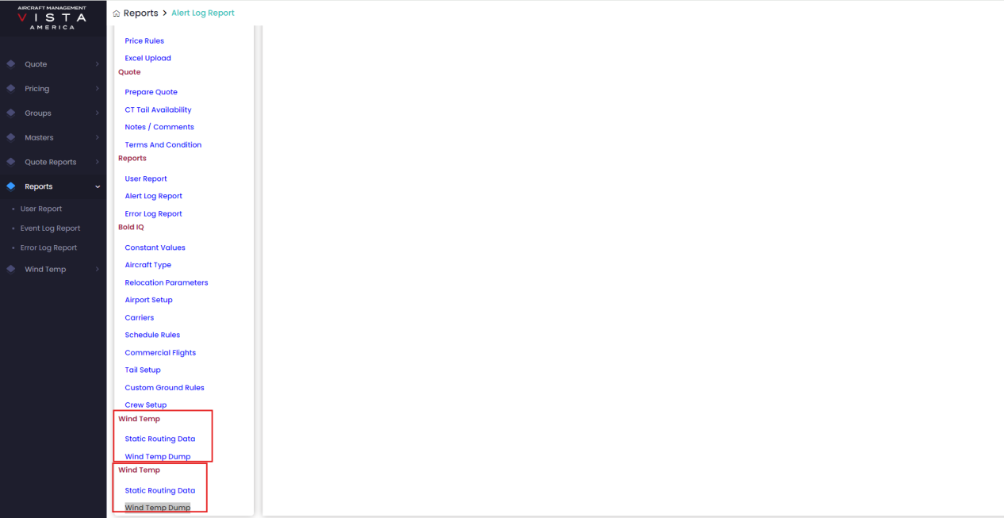

1. Reports-Error log report-When enter valid from date and to date and valid status and click search button, unwanted alert message is displayed - Closed-Fixed
2. Reports-Error log report-After select valid date, click Flying hour setup unwanted alert message is displayed. - Closed-Fixed

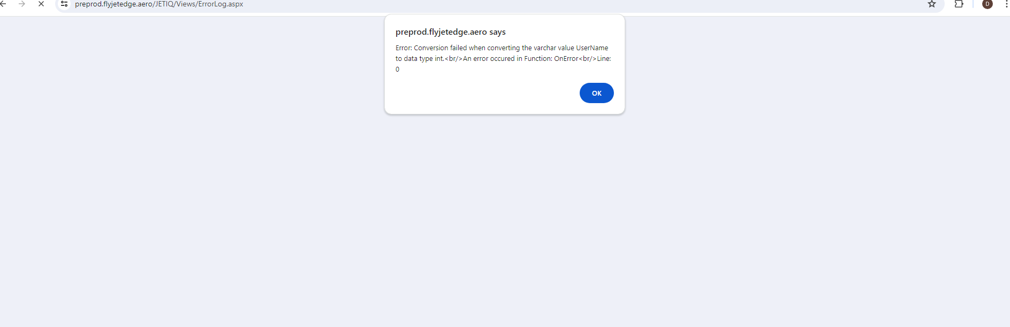

New Bugs:

1. Masters-Account-Add new-After enter valid details in account details, In contact details after click add contact button and without enter any details and click save button mandatory message is displayed but in mandatory message “Country” name detail is missed

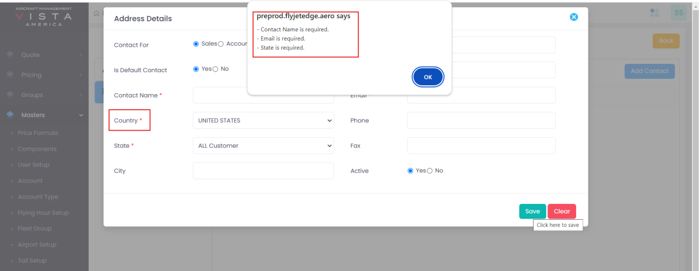

1. Masters-Airport setup-Add new-Without enter any value in airport details and click save button, mandatory alert message is displayed but access name is required is mentioned 2 times-Fixed

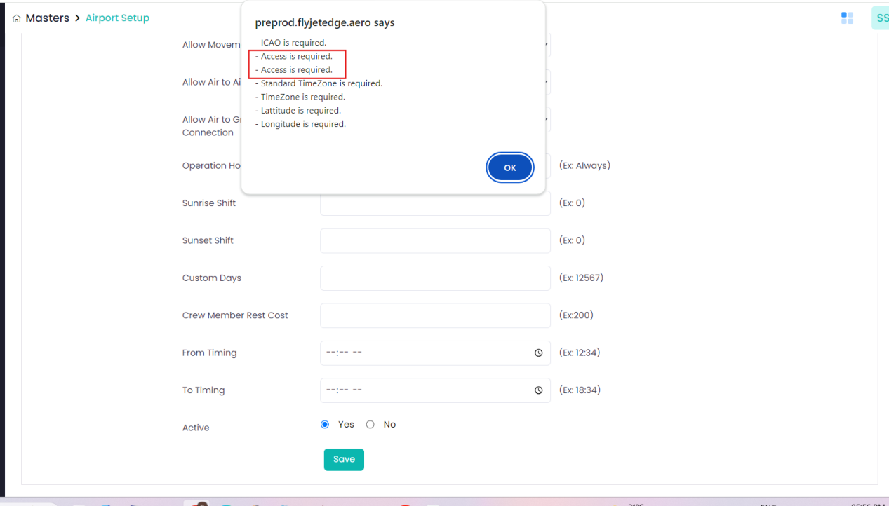

3.In Quote portal-In Forget Password- Need to change the background coz cannot easily able find the text box. Need to change the background colours

4.In Quote list, Once select valid from date and valid data and click search button, View symbol is moved away from the table

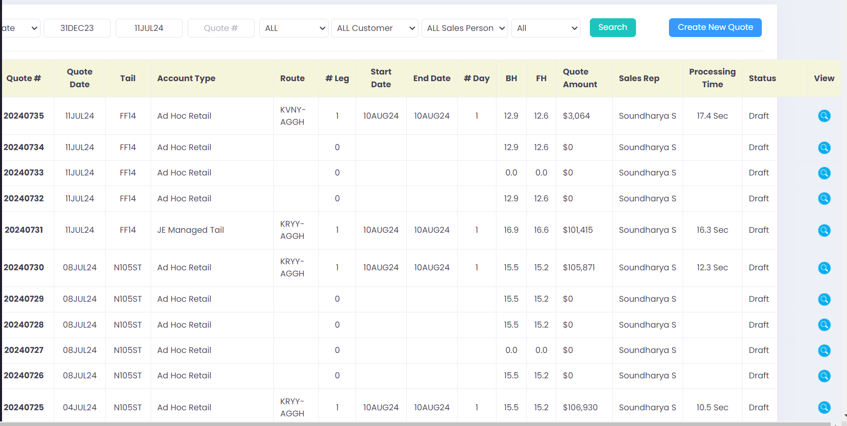

5.In Pricing-Price Rules- Once select valid from date and valid data and click search button, View symbol is moved away from the table-Fixed

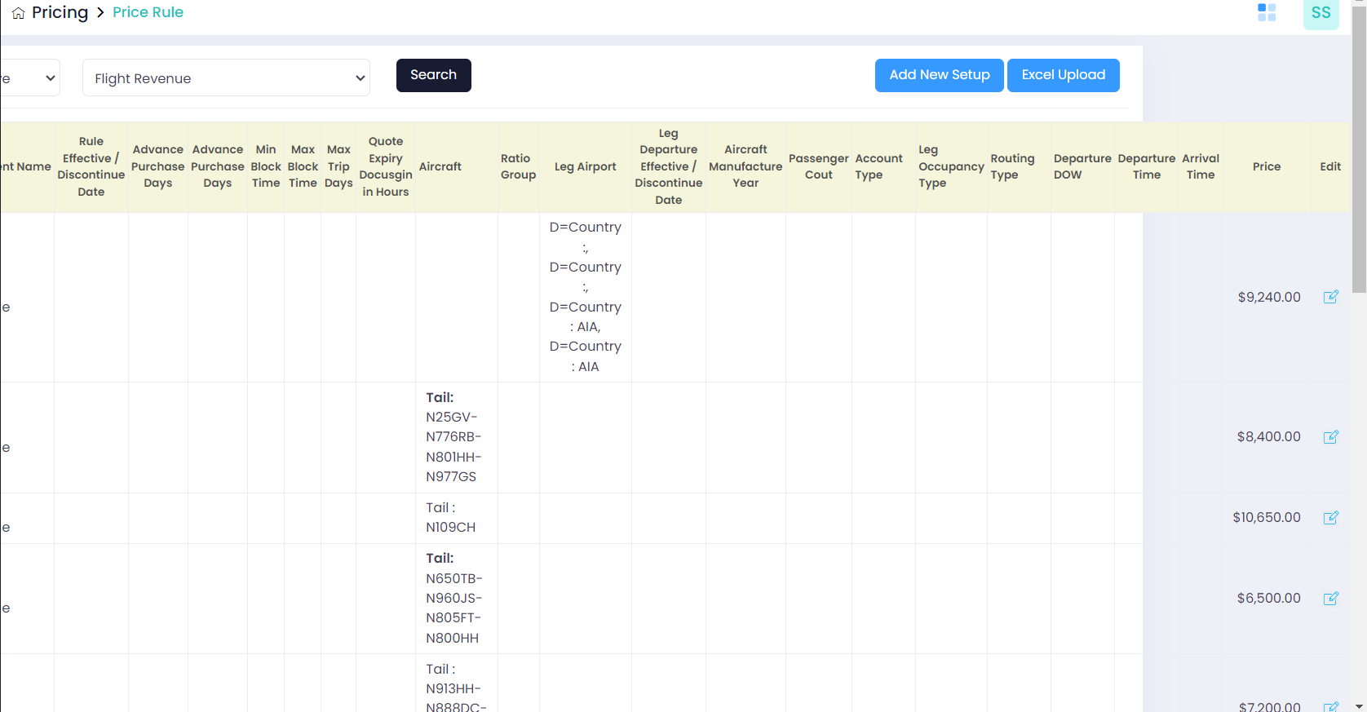

1. In Groups menu bar shows Account Group but in page shows Customer Group. But it should be same.

